Measurement of postoperative pain after shoulder surgery from a perioperative registry

Introduction
I was tasked to analyse a perioperative registry run between 2016 and 2026 at the Queen Elizabeth hospital, Gateshead, UK. Two hundred and thirty-one nerve blocks were performed for shoulder arthroscopy and arthroplasty. The same consultant anaesthetist shoulder and consultant surgeon performed all procedures.

All open and arthroscopic shoulder surgeries were performed under either interscalene or suprascapular nerve block depending on the perceived risk of phrenic nerve block and ipsilateral diaphragmatic paralysis. Nerve blocks were performed with: (1) local anaesthetic alone; (2) with adjuvant dexamethasone; and (3) with an additional nerve block such as intercostobrachial and subscapularis block.

Patient characteristics and baseline worst pain scores on movement, rest and at night over the previous 24 hours were collected by the Anaesthetist. Postoperatively, patients were tasked to record their worst pain scores on movement, at rest and at night on days 1, 3 and 7 after surgery. Data was collected by pain nurse telephone follow up at 7 days.

Summary of results
- The proportion of patients with adequate pain was < 25% on days 1, 3 and 7
- Pain scores on movement were reduced on day 3 with the addition of a second peripheral block compared to no adjuvant, difference 1.44 (0.18 to 2.71), P = 0.049.
- Pain scores at night were reduced on day 3 with the addition of a second peripheral block compared to dexamethasone, difference 1.71 (0.32 to 3.11), P = 0.032.
- Baseline pain at rest 0.252 (0.134 to 0.370), P < 0.001 and baseline pain at night 0.290 (0.128 to 0.385), P < 0.001 predicted postoperative pain
- Opioid rescue in recovery was administered in 7% of patients

I was asked to analyse the database with the following objectives and end points.

Primary objective
- To compare estimated mean marginal pain scores, adjusted for baseline pain, measured 1, 3 and 7 days after surgery on movement, at rest and at night in patients having a nerve block alone, or combined with dexamethasone or an additional nerve block.

Secondary objectives
- To calculate the proportion of patients with mild, moderate and severe pain measured 1, 3 and 7 days after surgery on movement, at rest and at night
- Determine if baseline preoperative pain predicts postoperative pain
- Promote the use of mixed models for repeated measures as the de facto standard for longitudinal studies comparing interventions repeated from baseline onwards.

Primary end point
- Estimated marginal means (95%) plotted versus over time (days 1, 3 and 7) and by adjuvant, adjusted for baseline pain.

Secondary end points
- Proportion of patients with mild (0 - 3); moderate (4 - 7); and severe (8 -10) pain
- Regression coefficients from mixed models for repeated measures analysis

Results
Characteristics
Patient characteristics grouped according to adjuvant are shown in Table 1. One hundred and ten (48%) patients received local anaesthetic alone; 96 (41%) patients received dexamethasone as well and 25 (11%) had an additional nerve block such as intercostobrachial or subscapularis block. Almost 4 out of 5 (79%) operations were arthroscopic and 1 out of 5 (21%) were open. Fourteen out of 15 (93%) blocks were interscalene and 1 out of 15 (7%) were suprascapular. Two-thirds of procedures (67%) were performed in awake/sedated patients.

Table 1. Patient characteristics. categorized according to adjuvant (Nil, dexamethasone and secondary block). All characteristics were collected.

Covariate | Levels | Nil  n (%) | Dexamethasone  n (%) | Additional Block  n (%) | Total  n (%) | P-Value
Gender | Female | 60 (55) | 43 (45) | 10 (40) | 113 (49) | 0.014
 | Male | 50 (45) | 53 (55) | 15 (60) | 118 (51)
Age decile | 20 to 29 | 5 (5) | 6 (6) | 6 (8) | 13 (6) | <0.001
 | 30 to 39 | 9 (8) | 9 (10) | 1 (4) | 19 (8)
 | 40 to 49 | 33 (21) | 13 (13) | 3 (12) | 39 (17)
 | 50 to 59 | 34 (31) | 23 (24) | 6 (24) | 63 (27)
 | 60 to 69 | 26 (24) | 36 (38) | 8 (32) | 70 (30)
 | 70 to 79 | 10 (9) | 8 (8) | 5 (20) | 23 (10)
 | 80 to 89 | 3 (3) | 1 (1) | 0 (0) | 4 (2)
Operation | Arthroscopy | 79 (70) | 82 (85) | 23 (92) | 182 (79) | <0.001
 | Open | 33 (30) | 14 (15) | 2 (8) | 49 (21)
Block | Interscalene | 99 (90) | 96 (100) | 21 (84) | 216 (94) | <0.001
 | Suprascapular | 11 (10) | 0 (0) | 4 (16) | 15 (7)
Anaesthetic | RA + GA | 61 (56) | 9 (9) | 7 (28) | 77 (33) | <0.001
 | RA | 49 (45) | 87 (91) | 18 (72) | 154 (67)
Opioid rescue | No | 109 (99) | 87 (91) | 29 (76) | 215 (93) | <0.001
 | Yes | 1 (1) | 9 (9) | 6 (24) | 16 (7)

Outcomes
Data was missing in 0% to 13% of quantitative outcomes (Table 2). Baseline pain was greater in the additional block group on movement and at rest.

Table 2. Duration and pain outcomes according to adjuvant (Nil, dexamethasone and secondary block), mean (SD)
Covariate | Collected  n (%) | Missing  n (%) | Nil | Dexamethasone | Additional block | P-value
Analgesia duration (h) | 216 (94) | 15 (6) | 22.5 (16) | 26.7 (19) | 24.5 (10) | 0.014
Surgery duration (min) | 231 (100) | 0 (0) | 48.1 (20) | 47.1 (17) | 61.3 (28) | <0.001
Baseline pain on movement | 217 (94) | 14 (6) | 7.4 (3) | 6.7 (3) | 7.6 (2) | 0.003
Baseline pain at night | 216 (94) | 15 (6) | 6.7 (3) | 6.3 (3) | 6.9 (2) | 0.168
Baseline pain at rest | 218 (94) | 13 (6) | 5.1 (3) | 4.7 (3) | 5.9 (3) | 0.017
Pain on movement | 206 (89) | 25 (11) | 5.9 (3) | 5.7 (3) | 5.1 (3) | 0.139
Pain at rest | 216 (92) | 15 (8) | 4.4 (3) | 4.2 (3) | 3.8 (3) | 0.410
Pain at night | 201 (87) | 30 (13) | 5.3 (3) | 5.5 (3) | 4.6 (3) | 0.103
Analgesics | 231 (100) | 0 (0) | 1.3 (1) | 1.2 (1) | 1.2 (1) | 0.480

The proportion of patients with adequate, moderate and severe pain on movement, at rest and at night at baseline changed little over the postoperative course (Fig 1). By day 7, only one quarter of patients had adequate pain on movement and at night and two fifths at rest.

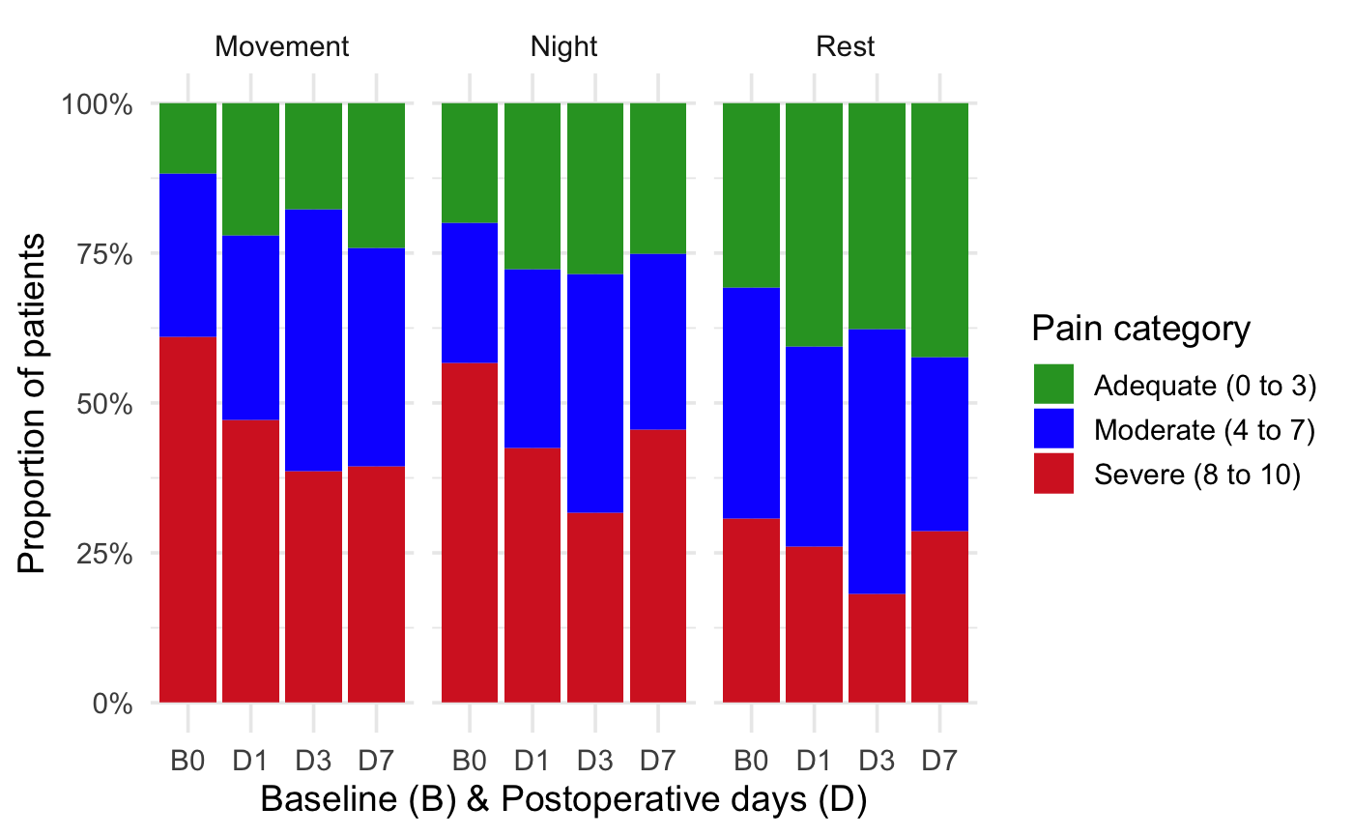

Plots of estimated marginal means (95%) versus Visit are shown in Fig, 2. Pain scores were reduced (Fig 2(a)) on day 3 with the addition of a peripheral block compared to no adjuvant, difference 1.44 (0.18 to 2.71), P = 0.049. In Fig 2(c) pain scores were reduced on day 3 with the addition of a peripheral block compared to dexamethasone, difference 1.71 (0.32 to 3.11), P = 0.032.

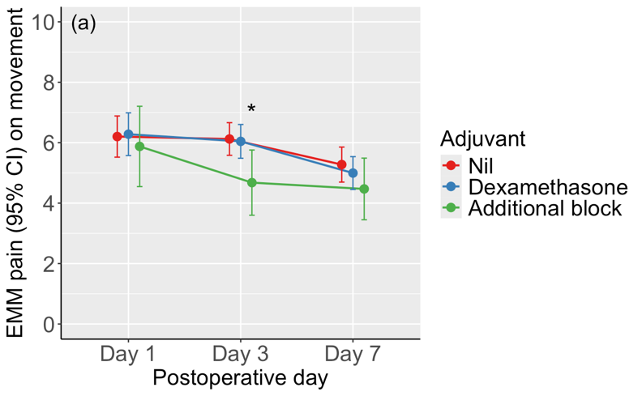
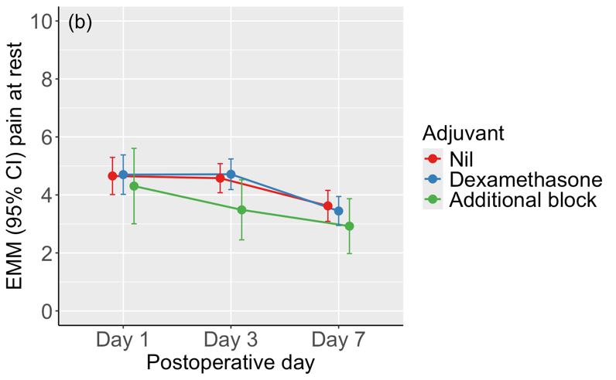
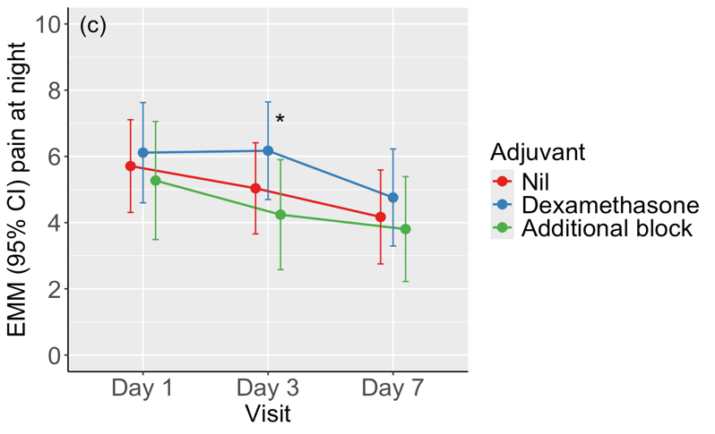

Independent predictors of postoperative pain
Baseline pain at rest 0.252 (0.134 to 0.370), P < 0.001 and baseline pain at night 0.290 (0.128 to 0.385), P < 0.001 predicted postoperative pain (Table 3)

Table 3
 | Pain on movement |  | Pain at rest |  | Pain at night
term | Estimate (95% CI) | P-value | Estimate (95% CI) | P-value | Estimate (95% CI) | P-value
(Intercept) | 5.236 (4.098 to 6.374) | 0.000 | 3.386 (2.578 to 4.193) | 0.000 | 3.876 (2.934 to 4.819) | 0.000
Adjuvant
Additional block | -0.327 (-1.577 to 0.923) | 0.666 | -0.349 (-1.563 to 0.866) | 0.636 | -0.482 (-1.723 to 0.759) | 0.522
Additional block: Visit Day 3 | -1.118 (-2.203 to -0.032) | 0.091 | -0.743 (-1.858 to 0.372) | 0.272 | -0.440 (-1.625 to 0.745) | 0.540
Additional block: Visit Day 7 | -0.479 (-1.714 to 0.757) | 0.523 | -0.350 (-1.562 to 0.863) | 0.634 | -0.181 (-1.464 to 1.101) | 0.816
Dexamethasone | 0.078 (-0.748 to 0.903) | 0.877 | 0.046 (-0.738 to 0.830) | 0.923 | 0.126 (-0.678 to 0.930) | 0.796
Dexamethasone: Visit Day 3 | -0.156 (-0.869 to 0.556) | 0.717 | 0.090 (-0.621 to 0.800) | 0.835 | 0.665 (-0.095 to 1.426) | 0.150
Dexamethasone: Visit Day 7 | -0.358 (-1.194 to 0.478) | 0.480 | -0.222 (-1.024 to 0.579) | 0.647 | -0.042 (-0.920 to 0.837) | 0.938
Pain
Baseline pain | 0.138 (0.003 to 0.272) | 0.093 | 0.252 (0.134 to 0.370) | 0.000 | 0.290 (0.176 to 0.404) | 0.000
Visit
Day 3 | 0.015 (-0.963 to 0.993) | 0.979 | -0.111 (-0.843 to 0.621) | 0.803 | -0.651 (-1.539 to 0.238) | 0.227
Day 3: Baseline pain | -0.014 (-0.130 to 0.103) | 0.846 | 0.007 (-0.100 to 0.114) | 0.916 | 0.003 (-0.105 to 0.111) | 0.964
Day 7 | -1.592 (-2.730 to -0.454) | 0.022 | -1.381 (-2.208 to -0.555) | 0.006 | -1.614 (-2.636 to -0.592) | 0.010
Day 7: Baseline pain | 0.094 (-0.041 to 0.229) | 0.250 | 0.069 (-0.049 to 0.188) | 0.335 | 0.041 (-0.080 to 0.161) | 0.580

Statistical note
The distribution of data was determined by q-q plots. Summary tables of categorical data were analysed by the Chi-squared test and qualitative data by one-way ANOVA. Pain data was arbitrarily categorized into mild (0 - 3); moderate (4 - 7); and severe (8 -10) for illustration of the proportional change in pain scores over one week.

The intrinsic problems with longitudinal pain data are the within-subject dependency of repeated measures, high drop-out rates and failure to account for variations in baseline pain. Two statistical tests are now outmoded. Repeated measures analysis of variance (RM ANOVA) requires completely balanced datasets. Baseline pain measures are incorporated into a Treatment × Visit global test of outcome rather than treated as fixed covariates. ANCOVA with baseline as a covariate corrects for baseline imbalance but over- or under-adjusts when treatment is not random. Moreover, ANCOVA copes best with only two time points (pre and post).

More recent examples of statistical tests used to measure longitudinal data are linear mixed effects models (LLM) and mixed models for repeated measures (MMRM). Despite their similar names their focus is quite different. Linear mixed-effects models (LLM) separate fixed effects from random effects. Fixed effects include factors such as type of block or local anaesthetic whereas random effects model the unique linear slopes and intercepts of subjects or clusters under specific conditions (conditional effects). The additional advantage of LMMs is that baseline pain may be incorporated as a fixed covariate.

In contrast, mixed models for repeated measures (MMRM) analyse population-averaged (marginal) effects. Estimated mean values, adjusted for other covariates, are calculated for each time point in each treatment group without need for imputation of values missing at random. Fixed effects within the MMRM model include Baseline Pain, Visits, Treatment, Baseline * Visit, and Treatment * Visit interactions. This permits the baseline effect on outcome to be taken account of across Visits. For these reasons, drug regulators such as the Food and Drug Administration (Bethesda, MA) recommend MMRMs for analysis of randomised controlled drug and pain trials of longitudinal data.

The MMRM model was specified with an unstructured covariance us (time | subject) matrix as below:

Pain on movement ~ Adjuvant + Visit + Baseline pain on movement + Visit*Baseline pain on movement + Visit*Adjuvant + us(Visit | Subject) where Visit = day 1, 3 or 7 and Adjuvant = nil, dexamethasone and secondary blocks.

Estimated marginal means (95%) were plotted versus over time (Days 1, 3 and 7) and by adjuvant. Statistical analysis used RStudio 2026.07.01 library. Packages used included tidyverse, mmrm, emmeans and kableExtra.

